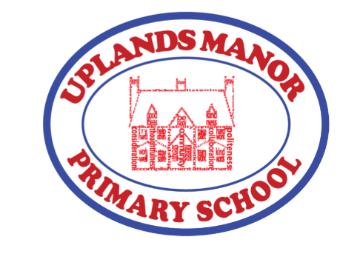
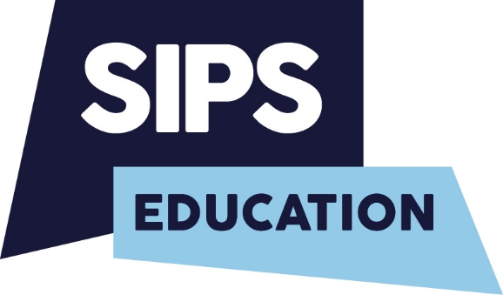

Privacy Notice for Pupils, Parents/Carers, Volunteers
Who we are
We are Uplands Manor Primary School, Addenbrooke Road, Smethwick, B67 6HT. We are a maintained primary school for children aged 3 to 11. This privacy notice explains how we collect, store and use personal data about our pupils, parents/carers. We Uplands Manor Primary School are the ‘data controller’ for the purposes of the General Data Protection Regulation (GDPR) and as such we are obliged to inform you of the information we hold on you and your child(ren), what we use it for, who we share it with, and for how long we keep it.
The Categories of Pupil & Parent Information that we Collect, Hold and Share
Pupil
Personal Information:
- Name
- Address
- Date of Birth
- Unique pupil number
Characteristics:
- Gender
- Ethnicity
- Religion
- Nationality
- Preferred Language
- Country of birth
- Free School Meal eligibility
- Special educational needs information - EHCP’s, statements, applications for support, care or support plans
- Medical Conditions and relevant medical information - NHS information, health checks, physical and mental health care, immunisation program and allergies)
- Attendance information. Session attended, number of absences and absence reasons and exclusion information
- Assessment information - data scores, tracking, and internal and external testing
- Behavioural information – details of support, including care packages, plans and support
- Safeguarding information
- Photographs - for internal safeguarding & security purposes, school newsletters, media and promotional purposes
- CCTV images

We may also hold data about pupils that we have received from other organisations, including other schools, local authorities and the Department for Education.

Parent/Carer
- Name
- Address
- Telephone number
- Email address
- Date of Birth
- Identification documents
- Emergency contact preference telephone number
- National insurance number
- Income/benefit details
Volunteers
- Name
- Address
- Telephone number
- Email address
- Date of Birth
- Identification documents
- Emergency contact preference telephone number
- National insurance number
- Income/benefit details
- DBS Clearance number

Why We Collect and Use This Information
We use the pupil and parent data to:
- support pupil learning
- to monitor and report on pupil progress
- to provide appropriate pastoral and medical care
- for safeguarding and pupil welfare purposes
- administer admissions waiting lists
- for research purposes
- to inform you about school events
- to assess the quality of our services
- to comply with the law regarding data sharing
Volunteers
- support pupil learning
- for safeguarding and pupil welfare purposes
- to comply with the law regarding data sharing
- undertake equalities monitoring
- ensure that appropriate access arrangements can be provided for volunteers

3. The lawful basis on which we use this information
Our lawful basis for collecting and processing pupil information is defined in GDPR under Article 6. The following elements of the article apply:
- Data subject gives consent for one or more specific purposes.
- Processing is necessary to comply with the legal obligations of the controller.
- Processing is necessary to protect the vital interests of the data subject (Pupil, parent/carers)
- Processing is necessary for tasks in the public interest or exercise of authority vested in the controller (the provision of education).
Our lawful basis for collecting and processing pupil information is further defined under Article 9, in that some of the information we process is deemed to be sensitive, or special category data. The following elements of the article apply:
- The data subject (Pupil, parent/carer, volunteer) has given explicit consent.
- It is necessary to fulfil the obligations of controller (school) or of data
subject. (pupil, parent/carer, volunteer)
- It is necessary to protect the vital interests of the data subject. (pupil, parent/carer, volunteer)
- Processing is carried out by a foundation or not-for-profit organisation (includes religious, political or philosophical organisations and trade unions)
- Reasons of public interest in the area of public health
- It is in the public interest

Collecting Pupil Information
A full breakdown of the information we collect on pupils can be found in the school’s data mapping document.
On some occasions, we process personal information on the basis of consent, for example, when we wish to take and use pupil images. Consent can be withdrawn at any time. We will make this clear when we ask for consent, and explain how consent can be withdrawn.
How We Use The Information You Provide To Us
Some of the reasons listed above for collecting and using pupils’ personal data overlap, and there may be several grounds, which justify our use of this data. Such reasons include:
The submission of the school census returns, including a set of named pupil records, is a statutory requirement on schools under Section 537A of the Education Act 1996. Putting the school census on a statutory basis means that schools do not need to obtain parental or pupil consent to the provision of information ensures schools are protected from any legal challenge that they are breaching a duty of confidence to pupils helps to ensure that returns are completed by schools
Storing pupil data
We hold pupil data whilst pupils attend our School. The file will follow the pupil when they leave the School. However, we have a legal obligation to keep information beyond their attendance at the school, which will be destroyed in line with our data retention schedule as outlined within out data mapping document. Please contact us if you would like further clarification on our retention timescales.
We have data protection policies and procedures in place, including strong organisational and technical measures, which are regularly reviewed. Further information can be found on our website.
Who We Share Pupil Information With
We routinely share pupil information with appropriate external agencies to meet our legal obligation or where we have sought your permission. The agencies who we routinely share pupil information with include:
- Our local authority – to meet our legal obligations to share certain information with it, such as safeguarding concerns and exclusions
- The Department for Education (DfE) - (for further information relating to Covid-19 Testing, please refer to the Privacy Notice for Covid-19 Testing and the DfE Privacy Notice)
- Educators and examining bodies
- Ofsted
- Suppliers and service providers – to enable them to provide a service as part of a contract – Music lesson providers; sports coaches; school meal providers; school photographers.
- Financial organisations
- Central and local government
- Our auditors
- Survey and research organisations
- Health authorities
- Public Health England
- Security organisations
- Health and social welfare organisations
- Professional advisers and consultants
- Charities and voluntary organisations
- Police forces, courts, tribunals
- Professional bodies
- Schools that the pupil’s attend after leaving us
If we transfer personal data to a country or territory outside the European Economic Area, we will do so in accordance with data protection law.
Please contact our Data Protection Lead (see contact details at the end of this privacy notice) who can provide you with further details of who we share pupil information with as recorded in our data mapping document.
Why We Share Pupil Information
We do not share information about our pupils with anyone without consent unless the law and our policies allow us to do so.
We share pupils’ data with the Department for Education (DfE) on a statutory basis. This data sharing underpins school funding and educational attainment policy and monitoring. We are required to share information about our pupils with our local authority (LA) and the Department for Education (DfE) under section 3 of The Education (Information about Individual Pupils) (England) Regulations 2013.
All data is transferred securely and held by DfE under a combination of software and hardware controls, which meet the current government security policy framework.
For more information, please see ‘How Government uses your data’ section.
Data Collection Requirements
To find out more about the data collection requirements placed on us by the Department for Education (for example; via the school census) go to https://www.gov.uk/education/data-collectionand-censuses-for-schools.
The National Pupil Database (NPD)
The NPD is owned and managed by the Department for Education and contains information about pupils in schools in England. It provides invaluable evidence on educational performance to inform independent research, as well as studies commissioned by the Department. It is held in electronic format for statistical purposes. This information is securely collected from a range of sources including schools, local authorities and awarding bodies.
We are required by law, to provide information about our pupils to the DfE as part of statutory data collections such as the school census and early years’ census. Some of this information is then stored in the NPD. The law that allows this is the Education (Information about Individual Pupils) (England) Regulations 2013.
To find out more about the NPD, go to https://www.gov.uk/government/publications/national-pupildatabase-user-guide-and-supporting-information.
The department may share information about our pupils from the NPD with third parties who promote the education or well-being of children in England by:
- conducting research or analysis
- producing statistics
- providing information, advice or guidance
The Department has robust processes in place to ensure the confidentiality of our data is maintained and there are stringent controls in place regarding access and use of the data. Decisions on whether DfE releases data to third parties are subject to a strict approval process and based on a detailed assessment of:
- who is requesting the data
- the purpose for which it is required
- the level and sensitivity of data requested: and
- the arrangements in place to store and handle the data
To be granted access to pupil information, organisations must comply with strict terms and conditions covering the confidentiality and handling of the data, security arrangements and retention and use of the data.
For more information about the department’s data sharing process, please visit: https://www.gov.uk/data-protection-how-we-collect-and-share-research-data
For information about which organisations the department has provided pupil information, (and for which project), please visit the following website: https://www.gov.uk/government/publications/national-pupil-database-requests-received
To contact DfE: https://www.gov.uk/contact-dfe
Requesting Access to your Personal Data and your Data Protection Rights
Under data protection legislation, parents and pupils have the right to request access to information about them that we hold, through a Subject Access Request. Parents/carers can make a request with respect to their child’s data where the child is not considered mature enough to understand their rights over their own data (usually under the age of 12), or where the child has provided consent. Parents also have the right to make a subject access request with respect to any personal data the school holds about them.
We will provide information in a way that is:
- Concise
- Transparent
- Intelligible
- Easily accessible
- Uses clear and plain language

If you would like to make a subject access request please contact our Data Protection Officer – Office/Data Manager email: headteacher@uplandsmanor.sandwell.sch.uk

Data subjects have the following rights with regards to their personal information, as follows:
- Confirmation that their personal data is being processed
- Access to a copy of the data
- The purpose of the data processing
- The categories of personal data concerned
- Who the data has been, or will be, shared with
- How long the data will be stored for, or if this isn’t possible, the criteria used to determine this period
- Where relevant, the existence of the right to request rectification, erasure or restrictions, or to object to such processing
- The right to lodge a complaint with the ICO or another supervisory authority
- The source of the data, if not the individual
- The safeguards provided if the data is being transferred internationally
You also have the right to:
- object to processing of personal data that is likely to cause, or is causing, damage or distress
- prevent processing for the purpose of direct marketing
- object to decisions being taken by automated means
- in certain circumstances, have inaccurate personal data rectified, blocked, erased or destroyed;
- claim compensation for damages caused by a breach of the Data Protection regulations 11.
Complaints.
We take any complaints about our collection and use of personal information very seriously. If you think that our collection or use of personal information is unfair, misleading or inappropriate, or have any other concern about our data processing, please raise this with us in the first instance. To make a complaint, please contact our Data Protection Lead within school – Office/Data Manager email: headteacher@uplandsmanor.sandwell.sch.uk

Contact Us
If you have any questions, concerns or would like more information about anything mentioned in this privacy notice, please contact our Data Protection Lead.
Our Data Protection Officer (DPO) is provided by SIPS Education Ltd. The following officers can be contacted via GDPR@sips.co.uk:
Laura Hadley
Sue Courtney-Donovan
Amanda Moore

You can also report a concern online to the Information Commissioners Office at https://ico.org.uk/concerns
Telephone Number 0303 123 1113
Address: Information Commissioner’s Office, Wycliffe House, Water Lane, Wilmslow, Cheshire, SK9 5AF 12.
Changes to this privacy notice

This privacy notice may be updated from time to time. We encourage you to check this privacy notice from time to time to ensure you understand how your data will be used and to see any minor updates. If material changes are made to the privacy notice, for example, how we would like to use your personal data, we will provide a more prominent notice (for example, email notification or correspondence of privacy notice changes).

